Big Data
Big Data refers to vast and rapidly growing volumes of data that are too large and complex for traditional data processing tools to manage. This data comes in many forms structured (e.g., tables), semi-structured (e.g., JSON, XML), and unstructured (e.g., text, images, video).

The 5 V’s of Big Data
- Volume: Refers to the huge amount of data generated every second-ranging from terabytes to petabytes. Example: YouTube uploads 500+ hours of video every minute.
- Velocity: The speed at which data is created, shared, and processed. Data streams in from sensors, social media, and transactions in real-time.
- Variety: Data comes in multiple formats-text, audio, images, videos, logs, sensor data, etc. Handling all these types together is complex
- Veracity: Refers to the trustworthiness and accuracy of the data. Inconsistent, duplicated, or noisy data can lead to wrong insights.
- Value: Not all data is useful. The key is extracting relevant data and turning it into business value through analytics.
Big Data Workflow

1. Data Integration
- Collect data from multiple sources: apps, sensors, websites, logs, etc.
- Tools used: Apache NiFi, Flume, Sqoop

2. Data Storage and Management
- Store data in data lakes or distributed file systems like HDFS
- Choose between cloud-based storage or on-premises infrastructure
- Tools used: Hadoop HDFS, Amazon S3, Google Cloud Storage

3. Data Analysis and Visualization
- Run analytics to extract insights using tools like Spark or Python
- Create dashboards and reports for decision-making
- Tools used: Apache Spark, Tableau, Power BI, Python (Pandas, NumPy)

Real-World Applications of Big Data
- Retail: Amazon and Flipkart use purchase history and browsing patterns to suggest products.
- Finance: Banks detect fraudulent transactions in real-time using Big Data models.
- Healthcare: Hospitals analyze patient records and medical data to improve diagnoses and treatment.
- Transportation: Uber uses GPS and traffic data to reduce wait times and improve driver routes.

Benefits of Big Data
- Better Decision-Making: Identify trends, customer needs, and risks for smarter strategies.
- Faster Innovation: Speed up product development by quickly analyzing market feedback.
- Enhanced Customer Experience: Personalize offerings based on behavior and preferences.
- Operational Efficiency: Detect inefficiencies and automate repetitive tasks.
- Risk & Threat Detection: Monitor suspicious activity and prevent financial fraud or cyberattacks.
PySpark
PySpark is the Python API for Apache Spark, designed for big data processing and analytics. It lets Python developers use Spark's powerful distributed computing to efficiently process large datasets across clusters. It is widely used in data analysis, machine learning and real-time processing.

Uses:
- Perform batch and real-time processing on large datasets.
- Execute SQL queries on distributed data.
- Run scalable machine learning models.
- Stream real-time data from sources like Kafka or TCP sockets.
- Process graph data using GraphFrames.
Key Features & Concepts
- Distributed Processing: PySpark breaks down massive datasets and processes them across a "cluster" (a group of connected machines) in parallel, rather than relying on a single computer.
- DataFrames: The primary data structure. They organize data into named columns, similar to tables in a relational database or a Pandas DataFrame.
- SparkSession: The entry point for writing any PySpark code. It allows you to connect to the Spark cluster and manipulate data.
- Spark SQL: Enables users to run standard SQL queries directly on top of their distributed data.
- Integrations: Easily works with machine learning libraries (MLlib) and integrates with standard Python data ecosystems like Pandas and NumPy.

Architecture

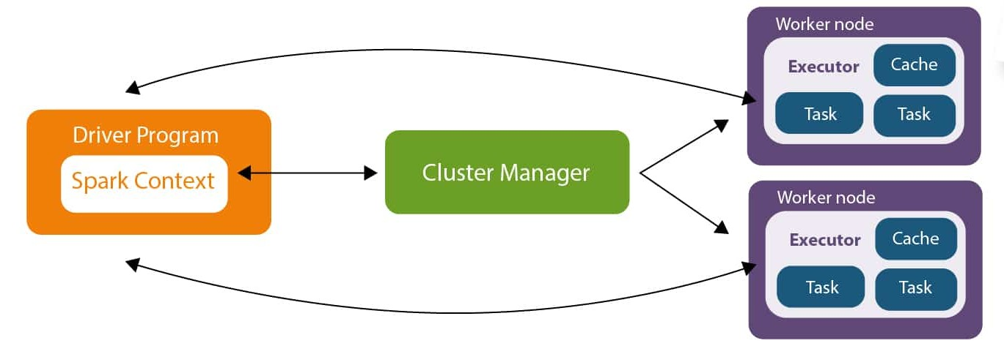

Driver Program
- Main application process.
- Creates SparkSession.
- Converts user code into tasks.
- Sends tasks to executors.

Cluster Manager
Allocates resources to Spark applications.
Examples:
- Standalone Cluster Manager
- YARN
- Mesos
- Kubernetes

Worker Nodes
Machines where actual computation happens.

Executors
Processes running on worker nodes that:
- Execute tasks.
- Store data in memory.
- Return results to the driver.
Cluster Manager
The Cluster Manager is responsible for managing and allocating resources in a Spark cluster. It acts as an intermediary between the Spark application and the worker nodes. When a Spark application is submitted, the Cluster Manager assigns CPU cores and memory to the application and launches executors on worker nodes.
Spark supports different cluster managers such as:
• Standalone Cluster Manager – Spark's built-in resource manager.
• Apache Hadoop YARN – Commonly used in Hadoop ecosystems.
• Apache Mesos – General-purpose cluster manager.
• Kubernetes – Container-based resource management.
SparkSession
SparkSession is the entry point to Spark functionality. Introduced in Spark 2.0, it combines the functionalities of SQLContext, HiveContext, and SparkContext into a single interface. It is used to create DataFrames, execute SQL queries, and interact with various Spark modules.
A Spark application starts by creating a SparkSession object.
- Features of SparkSession
- Entry point for DataFrame and SQL APIs.
- Provides access to SparkContext.
- Supports reading and writing data from multiple sources.
- Integrates with Spark SQL, Streaming, and Machine Learning libraries.

SparkContext
SparkContext is the core component of Apache Spark that establishes a connection between the Spark application and the cluster. It coordinates the execution of tasks across the cluster and serves as the entry point for low-level RDD operations. It is automatically created when a SparkSession is initialized.

Functions of SparkContext
- Connects to the Cluster Manager.
- Creates RDDs (Resilient Distributed Datasets).
- Schedules and distributes tasks.
- Monitors execution of jobs.
- Manages communication with executors.

Driver Node
The Driver Node is the master process of a Spark application. It contains the main program and is responsible for controlling the entire execution process.

Responsibilities of Driver Node
- Creates SparkSession and SparkContext.
- Converts user code into Spark jobs.
- Divides jobs into stages and tasks.
- Schedules tasks for execution.
- Communicates with the Cluster Manager.
- Collects results from executors and returns them to the user.

Worker Node
A Worker Node is a machine in the cluster that performs the actual computation. Worker nodes contain executors, which execute tasks assigned by the Driver Node.

Responsibilities of Worker Nodes
- Run executor processes.
- Execute tasks in parallel.
- Store intermediate data in memory or disk.
- Return results to the Driver Node.
A Spark cluster typically contains multiple worker nodes, enabling distributed and parallel processing of large datasets.

Client Mode
In Client Mode, the Driver Program runs on the machine from which the application is submitted. The executors run on the cluster's worker nodes.

Working
- User submits the application.
- Driver Program starts on the local machine.
- Driver communicates with the Cluster Manager.
- Cluster Manager launches executors on Worker Nodes.
- Executors perform computations and return results to the Driver.

Characteristics
- Driver runs outside the cluster.
- Easy to monitor and debug.
- Suitable for development and testing.
- Requires continuous connection between the client machine and the cluster.

Advantages
- Simple debugging.
- Real-time access to application logs.
- Faster interaction during development.

Disadvantages
- Application fails if the client machine disconnects.
- Not ideal for long-running production jobs.

Command
spark-submit --deploy-mode client app.py

Cluster Mode
In Cluster Mode, the Driver Program runs inside the cluster on one of the worker nodes. The client machine only submits the application and does not participate in execution.

Working
- User submits the application.
- Cluster Manager launches the Driver inside the cluster.
- Driver requests resources from the Cluster Manager.
- Executors are started on Worker Nodes.
- Tasks are executed and results are stored or returned.

Characteristics
- Driver runs within the cluster.
- Suitable for production environments.
- More reliable and fault tolerant.
- User can disconnect after submitting the application.

Advantages
- Better resource utilization.
- High availability and fault tolerance.
- Application continues even if the client machine is disconnected.

Disadvantages
- Debugging is relatively difficult.
- Driver logs must be accessed from the cluster.

Command
spark-submit --deploy-mode cluster app.py

